**Code Analysis**

1. Find and correct the errors in the following code segment:

public class MyProgram

{

public static void main(String[] args)

{

City aCity = new City();

Robot smithers = new Robot(City aCity, int 1, int 4, Direction NORTH);

smithers.move();

}

}

Correct Version:

import becker.robots.*;

public class MyProgram

{

public static void main(String[] args)

{

City aCity = new City();

Robot smithers = new Robot(aCity, 1, 4, Direction.NORTH);

smithers.move();

}

}

1. Find and correct the errors in the following code segment:

public class Robot

{

public static void main(String[] args)

{

Robot smithers = new Robot(aCity, 1, 4, Direction.NORTH);

City aCity ();

smithers.move();

}

}

Correct Version:

import becker.robots.*;

public class Robot

{

public static void main(String[] args)

{

City aCity = new City();

Robot smithers = new Robot(aCity, 1, 4, Direction.NORTH);

smithers.move();

}

}

1. Trace the following section of code and draw a diagram to represent the **initial** and **final** situations.

public static void main(String[] args)

{

City aCity = new City();

Robot smithers = new Robot(aCity, 4, 3, Direction.WEST);

Thing thing1 = new Thing (aCity, 2, 3);

Wall wall1 = new Wall (aCity, 5,4, Direction.SOUTH);

smithers.turnLeft();

smithers.move();

smithers.turnLeft();

smithers.move();

}

Initial:

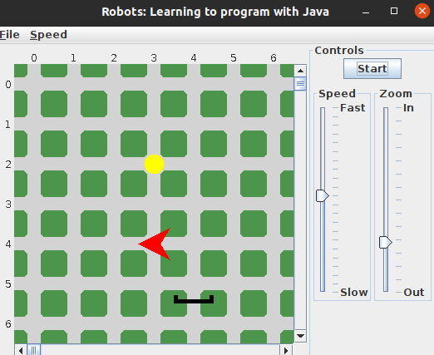

Final:

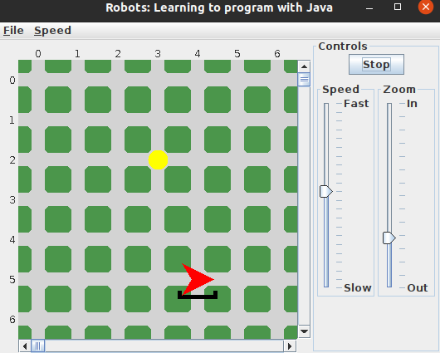

1. Trace the following section of code and draw a diagram to represent the **initial** and **final** situations.

public static void main(String[] args)

{

City aCity = new City();

Robot smithers = new Robot(aCity, 2, 3, Direction.NORTH);

Robot homer = new Robot(aCity, 2, 4, Direction.NORTH);

Wall wall1 = new Wall (aCity, 2,4, Direction.NORTH);

Wall wall2 = new Wall (aCity, 2,2, Direction.EAST);

smithers.turnLeft();

smithers.move();

homer.turnLeft();

homer.move();

}

Initial:

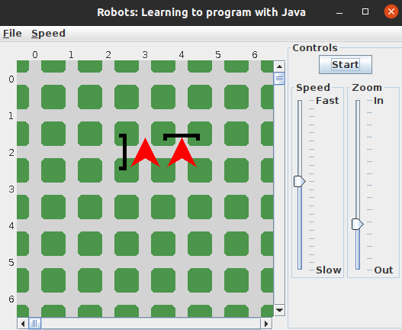

Final:

